What makes Tallahassee, Tallahassee?
A SENSE OF PLACE
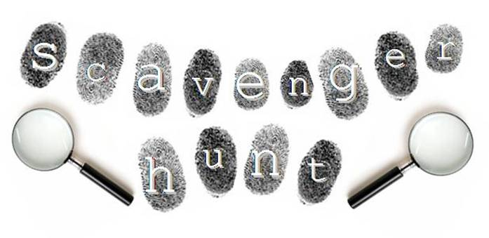

The purpose of this project is to establish a Sense of Place for Tallahassee. What makes Tallahassee unique and a great place to live? Instead of collecting objects for this scavenger hunt, each four to six-person teams will collect pictures with at least one member of the team in the photo of 20 of the 30 listed locations. Each team will then create a PowerPoint (not Mac or Apple format) using the pictures. Each picture must have an explanation or narration that gives background information about the place that is not evident from the picture. For example, when was the building built and after whom was it named? Create a map to include in the PPT that includes the location of each of your pictures
Points: 40 pts = 2 point per picture (if a true representation of the listed location)
20 pts = for explanations & 10 pts = interesting story line
30 pts = for a Google map, ArcGIS, or other map showing each of the locations.
= 100 points for a successful scavenger hunt PowerPoint presented to class
List of SENSE OF PLACE Examples:
1. An example of what makes Tallahassee unique - explain
2. A monument to a historical event (before 1980) - explain
3. A historic building downtown (dating prior to 1900) –explain
4. A canopy road – identify & be very careful
5. A government building (not the capital) – identify & tell what it is used for
6. A statute of a famous resident (or former resident) – identify or explain
7. An example of Native American presence - explain
8. An example of Spanish presence - explain
9. An example of French presence - explain
10. A sports stadium or concert hall (not Chiles) - for whom is it named – explain
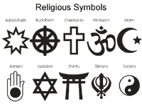
11. A view of the cityscape – identify what is shown
12. A location of a civil rights event - explain
13. An ethnic grocery store - identify
14. A cemetery - example of interesting grave marker
15. Examples of 3 DIFFERENT religions’ architecture
16. A museum – what kinds of exhibits are found there?
17. An example of a rundown shopping area
18. An example of one of Tallahassee’s lakes – identify & estimate its size
19. A authentic (not a chain) ethnic restaurant
20. A recreation area – identify and tell what kinds of recreation takes place there
21. A traffic “calming” device – explain
22. An example of an older area that is being renewed or revitalized – identify & explain
23. An example of public transportation
24. An example of Tallahassee’s flora or fauna
25. An example of a public service, such as a library, police station, fire department, etc.
26. An example of PLACELESSNESS – could be found in almost any city or town – and found here
27. An example of Tallahassee’s SITE
28. An example of Tallahassee’s SITUATION
29. An example of Tallahassee’s INFRASTRUCTURE
30. Something not listed that makes you love living in Tallahassee.
Adapted by Nancy H. Watson, Lawton Chiles High School, 2016 from Judy Ware, APHG Reader extraordinaire.

