China's Insatiable Appetite When 1 billion people want to eat a lot of meat, it can be a problem for everyone.
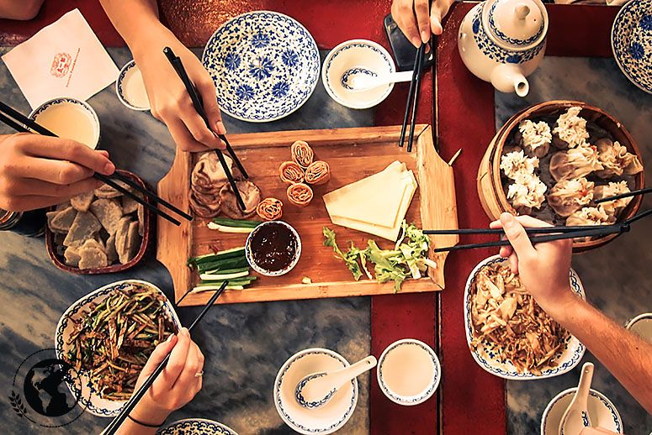(Photo: Daniel Frauchiger)
Jun 29, 2015
Sarah McColl has written for Yahoo Food, Bon Appetit, and other publications. She's based in Brooklyn.
If you're wondering which country consumes the most of a given food in the world, the odds are good that the answer is China. Sure, it's the most populous nation in the world, and everyone has to eat. But China's still relatively new status as a star in the global economy—and the huge number of newly minted middle- and upper-class citizens created by economic liberalization and a massive rural-urban migration—has the country clamoring for the culinary trappings of the good life. In many cases, that means more protein, be it meat or seafood. It's a growing hunger that, in many ways, is realigning the international food chain.
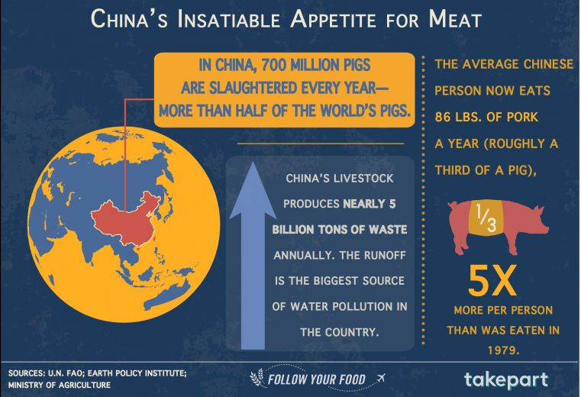
(Illustration: Lauren Wade)
To understand just how fundamental the pig is to Chinese culture, consider that the words “meat” and “pork” are the same in Mandarin, and the character for “family” is a pig under a roof. Pigs will soon eat half of the world’s feed crops, filling the troughs of industrial-sized operations, where the average herd has grown from just under a thousand to more than 8,000 hogs. In China, livestock holds the lion’s share of blame for water and soil pollution, and antibiotics trickle into the system via the 11 pounds of manure the average pig produces each day, resulting in billions of tons of waste per year.
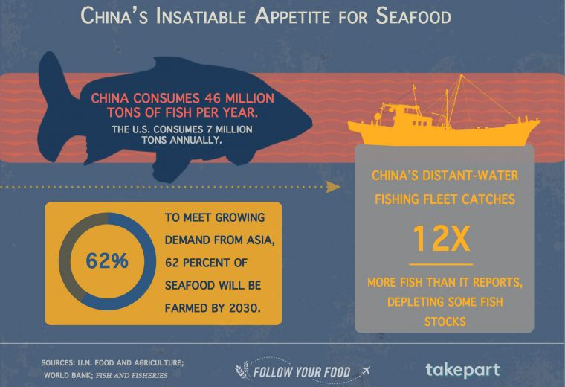
(Illustration: Lauren Wade)
China has a hand in harming communities and environments on the other side of the world thanks to its growing demand for livestock feed. In Brazil, 62 million acres of land—parts of which were Amazon rainforest—are now used to cultivate GMO soybeans. Argentina, moving away from its cattle tradition, has destroyed thousands of acres of forest to grow soybeans—almost all of which are exported to China—using herbicides linked to birth defects and an increased risk in cancer. Communities around Argentina are now also dealing with health issues caused by chemical drift, water contamination, and an array of issues related to the widespread spraying of pesticides on soybean fields.
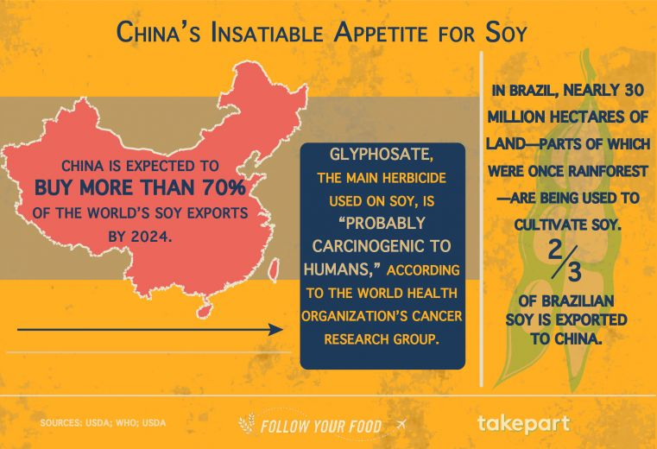(Illustration: Lauren Wade)
China produces, eats, and processes more seafood than anyone else on Earth, contributing one-third of the global supply. On a list of the top seafood-consuming countries in the world, China eats more fish than the next 10 countries combined, totaling more than 50 million tons per year. Not any chum will do: China’s growing middle class doesn’t want to eat freshwater fish from the country's polluted lakes and waterways. Rather, it prefers to dine on the likes of tuna, sea cucumber, and abalone. To keep up with demand, China’s 70,000-boat overseas fishing fleet has been caught fishing illegally off the coasts of Japan, Argentina, and many places in between. Meanwhile, the FAO reports that 80 percent of the world’s fish stocks are fully exploited or overexploited.
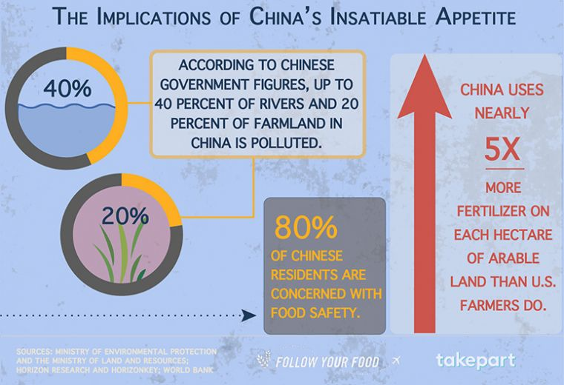
(Illustration: Lauren Wade)
When a country of more than 1 billion people has an appetite for anything, it causes ripple effects and sets records. Drinking only two bottles of wine per person per year made China the world’s largest consumer of red wine. Each bon vivant in France, for contrast, knocks back 69 bottles per year. Still, feeding China does have global implications. After all, the expansion of livestock production is one of the primary causes of human-made climate change. To feed China’s livestock, we devote vast areas of land to soybeans and corn grown with pesticides, herbicides, and fungicides. While those practices may maximize production, they obliterate farming ecosystems and wipe out the genetic diversity of plants, leaving crops vulnerable to pests and disease and our global food supply susceptible to catastrophic losses.

