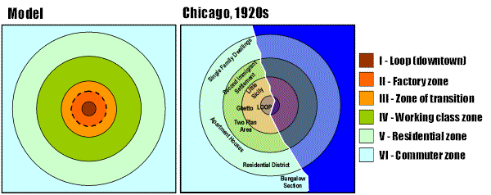

In 1925, E.W. Burgess presented an urban land use model, which divided cities in a set of concentric circles expanding from the downtown to the suburbs. This representation was built from Burgess's observations of a number of American cities, notably Chicago.
According to this model, a large city is divided in concentric zones with a tendency of each inner zone to expand in the other zone. Urban growth is thus a process of expansion and reconversion of land uses. For instance on this figure zone II (Factory zone) is expanding towards zone IV (Working class zone), creating a transition zone with reconversion of land use.
Although the Burgess model is simple and elegant, it has drawn numerous criticisms:
* The model is too simple and limited in historical and cultural applications up to the 1950s. It is a product of its time.
* The model was developed when American cities were growing very fast in demographic terms and when individual transportation was still uncommon. Expansion thus involved reconversion of land uses. This concept cannot be applied in a contemporary (second half to the 20th century) context where highways have enabled urban development to escape the reconversion process and settle in the suburbs.
* The model was developed for American cities and has limited applicability elsewhere. It has been demonstrated that pre-industrial cities, notably in Europe, did not at all followed the concentric circle model. For instance, in most pre-industrial cities, the center was much more important than the periphery, notably in terms of social status.
* There were a lot of spatial differences in terms of ethnic, social and occupational status, while there were low occurrence of the functional differences in land use patterns. The concentric model assumed a spatial separation of place of work and place of residence, which was not the generalized until the twentieth century.
However, the Burgess model remains useful for approximation of concentric urban development and as a way to introduce the complexity of urban land use.

