Central Place Theory
• A Central Place is a settlement which provides one or more services for the population living around it.
• Simple basic services (e.g. grocery stores) are said to be of low order while specialized services (e.g. universities) are said to be of high order.
• Having a high order service implies there are low order services around it, but not vice versa.
• Settlements which provide low order services are said to be low order settlements.
Settlements that provide high order services are said to be high order settlements.
• The sphere of influence is the area of under influence of the Central Place.
• The minimum population size required to profitably maintain a service is the threshold population.
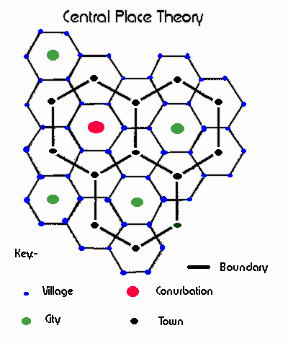
• Factors affecting a fall in the threshold population are
- A decrease in population
- Change in tastes
- Introduction of substitutes

Conclusions That Can be Made About Central Places
- The larger the settlements, the fewer their number
- The larger a settlement, the farther away a similar size settlement is
- The Range increases as the population increases
- The larger the settlement, the higher the order of its services. Deviations to this rule are:
  - Tourist resorts that have a small population but large number of functions.
  - Dormitory towns that have a large population but a small number of functions.
• Christaller made a number of assumptions such as:
All areas have
- an isotropic (all flat) surface
- an evenly distributed population
- evenly distributed resources
- similiar purchasing power of all consumers
• The theory points out that to prevent spheres of influence overlapping or having gaps, the best shape was a hexagon.
• The breaking point is where the consumer is equidistant from two/more similar services i.e. where the consumer is equally far from two or more centers.
• The formula to calculate it is djk=dij/(1+Square Root of(Pi/Pj)) where djk is the distance from j to k, dij is the distance between two towns, Pi/Pj are the populations of j and i and i is the bigger town.

