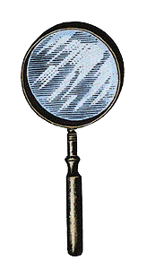
Decoding Verbs

Below are a list of the most often used verbs for AP essays and descriptions/definitions to help clarify the intent of the question

Identify: name (who or what)

Define: state, describe, give the meaning of

Describe: give an account of; tell about; give a word picture of.

Discuss: talk over, write about; consider or examine by argument or from various points of view; debate; present the different sides of.

Explain: make clear or plain; make clear the causes or reasons for; make known in detail; tell the meaning of.

Discuss: talk over, write about; consider or examine by argument or from various points of view; debate; present the different sides of.

Compare: examine for the purpose of noting similarities and differences.

Contrast: examine in order to show dissimilarities or points of difference.

Analyze: determine the component parts; examine their nature and relationship.

Assess/Evaluate: judge the value or character of something; appraise’ evaluate the positive points and the negative ones: give an opinion regarding the value of; discuss the advantages and disadvantages of.

Be alert for cues that will direct you answer:

Choose one (or two, or three, etc)

Using one of the examples above, explain…..

Nancy Watson/AP Annual Conference/July 20, 2012 AP Human Geography

Success with FRQs comes with PRACTICE!
Preparing Students for Free Response Questions
- Practice reading and interpreting MAPS, charts, graphs, and photos
- Practice at developing a SPATIAL perspective in viewing the world around us
- Practice at interpreting and APPLYING geographic MODELS
- Practice using the specific geographic VOCABULARY
- Practice in MAKING CONNECTIONS between geographic themes and real world situations.

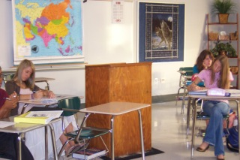
Tackling the FRQ
- Read the whole question before beginning to answer
- What does the question ask the student to do?
  - Identify
  - Define
  - Explain
  - Compare/Contrast
  - Analyze
  - Evaluate
  - Give examples
- FRQs have more than one part, so it may ask the student to do different things in each part
- Use self scoring and peer scoring using the rubric to familiarize the student with how they earn points
- Practice with FRQs will make students feel more confident when exam time comes

Approach for maximizing FRQ Scores:
- Brainstorm, plan, and at the very least bullet information to include in the answer
- Answer in the format of the question – A, B, C, etc., and always in paragraph form
- Questions may be answered in any order, but label each question at the top of each page
- No introduction, thesis, or conclusion needed – geographic principles and examples are needed
- Consider content from throughout the course to answer the questions
- Use geographic terminology when possible (knowing the vocabulary is essential)
- Use examples when required or when it will strength your answer
- Write LEGIBLY!!!!!

Common Mistakes
- Students fail to read and follow the instructions on the exam booklet when instructed to do so.
- Do NOT skip lines
- Write in INK
- NO bullets or outlines – write in paragraph form
- Write on the lined pages provided in the booklet. Do NOT write the answer on the prompt page.
- Strikethrough incorrect infomation information. Any content with a strikethrough will not be considered in scoring the answer.
- Write LEGIBLY!!!!
Nancy Watson/AP Annual Conference/July 20, 2012 AP Human Geography

