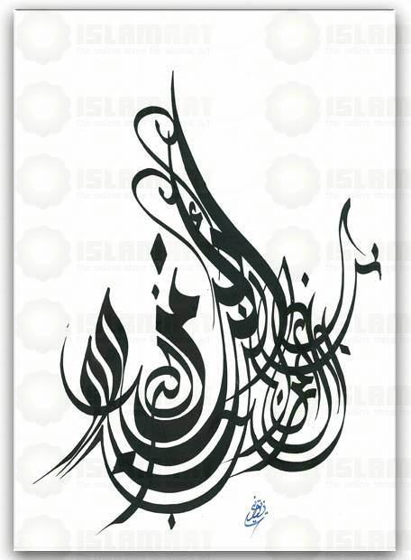
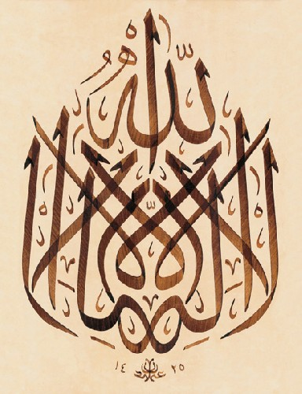
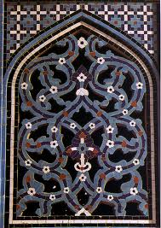
Muslim Achievements
in the Arts

Use an 8 ½ by 11 sheet of unlined paper turned landscape. Fold the paper into half to create a brochure.
- Create an appropriate Title on the front fold -
  - Use an appropriate decoration. (Remember Muslims do not portray living things in their art)
  - Include the author (that would be you) on the front
- Inside on the left fold –
  - Describe an Islamic achievement in Art, Science, Medicine, Mathematics, Literature, etc.
  - Identify the person responsible
  - Create a sketch of the achievement
  - Explain the significance of the achievement and any historical precedent.
- Inside on the right fold –
  - Describe another Islamic achievement in Art, Science, Medicine, Mathematics, Literature, etc
  - Identify the person responsible
Arabesque Tiles
Your Name & Class

  - Create a sketch of the achievement
  - Explain the significance of the achievement and any historical precedent.
- On the back –
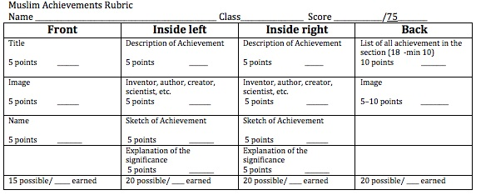
  - Create a list of all of the achievements mentioned in the 10.3 section.
  - Include some appropriate artwork
7. Review your work for spelling accuracy and neatness. Late work will not be accepted. See 9 Weeks Calendar for the due date.

