Byzantine, Russian & Seljuk Empire Map Activity

- Using the map on page 299 in your text, label the following

  - Rome
  - Venice
  - Constantinople
  - Damascus
  - Jerusalem
  - Baghdad
  - Alexandria
  - Cairo
  - Bukhara
  - Kiev
  - Novgorod
  - Toledo
  - Cordoba

- Label the Mediterranean Sea, Black Sea, Caspian Sea, Red Sea, Persian Gulf, Indian Ocean & Atlantic Ocean. Color these water areas blue
- Color the extent of the Byzantine Empire one color
- Color the extent of the Russian Empire a different color
- Color the extent of the Seljuk Empire a third color
- Go Back to page 153 in your text. Use a dark pen or sharpee to draw a line around the extent of the Roman Empire between 265 BC and 117 AD
- Create a key to explain the colors and symbols (line) on your map
- Hand in your map (before you paste it in your notebook) Leave a left side page for it in this unit.
- In complete sentences answer the following questions , below your map:
  - What major areas were lost after the fall of Rome in 476AD?
  - What activity suggests the reason for the Seljuk Empire reaching East?
  - Why do you think the Russian Empire was influenced by the Byzantine Empire?
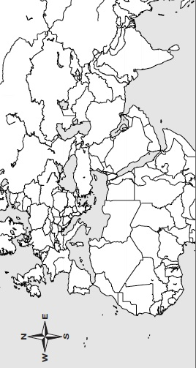
Mapping the Byzantine Empire
Answer Questions here:

