DOCUMENT A

In 1600, a general named Tokugawa Ieyasu won an important military victory and united all of Japan under a central government. He had the emperor name him shogun and took measures to ensure that the title and the power that went with the title stayed in the Tokugawa family. The center of Tokugawa government was the village of Edo, which later became known as Tokyo.

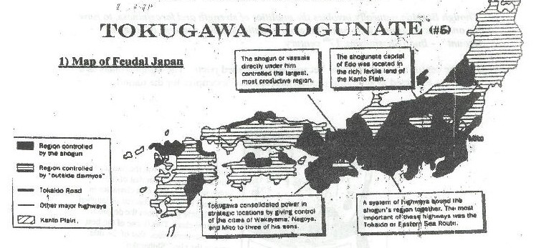

DOCUMENT B

The Tokugawa Shogun’s Laws Restricting Christianity, 1587:
- Japan is the country of gods, but has been receiving false teachings from Christian countries. This cannot be tolerated any further.
- The missionaries approach people in provinces and districts to make them their followers, and let them destroy shrines and temples. This is an unheard-of outrage.
- They commit the illegal act of destroying the teachings of Buddha prevailing in Japan. These padres cannot be permitted to remain in Japan.

DOCUMENT C

The Closed Country Policy, enacted 1635:

- Japanese ships are strictly forbidden to leave for foreign countries.
- No Japanese is permitted to go abroad. If there is anyone who attempts to do so secretly, he must be executed.
- If there is any place where the teachings of padres (Christianity) is practiced, the two you must order a thorough investigation.
- If there are any Southern Barbarians (Westerners) who propagate the teachings of padres, or otherwise commit crimes, they may be incarcerated in prison.
- All incoming ships must be carefully searched for the followers of padres.
- All foreigners are excluded from trade with Japanese, except for the Chinese and the Dutch, who may trade only at Nagasaki.

DOCUMENT D

System of Sankin-Kotai:

All daimyo were obligated to spend several months each year at the shogun’s court in Edo (former name of Tokyo) leaving their wives and children behind. This meant that the daimyo had to spend large amounts of money and time traveling to and from Edo.
Movement around the country was controlled with barriers on the main routes at which travelers would be stopped to have their travel permits examined.
The Tokugawa proved to be very effective and Japan enjoyed a long spell of Peace. This left a dilemma for the samurai: the job of a warrior is to fight, and without war the samurai needed something to do.

DOCUMENT E

Although a Samurai acquired skills in the art of war, in times of peace he was to cultivate more peaceful pursuits.

“Though Bushido naturally involves the qualities of strength and forcefulness, to have this one side developed is to be nothing but a rustic (simple) samurai of no great account” – Budo Shoshinshu, 17th century

Over the centuries many Samurai became accomplished poets. The samurai class a whole was expected to act moral (honest) and spiritual examples for the nation.

Kabuki Theater: During Pax Tokugawa, the image of the samurai changed from that of the noble warrior to that of a character in a Kabuki Play, to be cheered or laughed at by theater goers from the despised merchant class. This is one of the best known samurai roles, that of the title role in the play “Shibaraku.” Extravagant make-up, costumes, and swords were used.

DOCUMENT F

What is a haiku?

A haiku is a short poem that describes a special moment. Written in a very direct manner, a haiku tells the who, what, where, and when of a given moment as experienced through the five senses – sight, smell, sound, touch, and taste.
Haikus:
- Use the present tense;
- Use concrete images;
- Do not rhyme;
- Have 17 syllables, usually in 3 lines, sometimes a 5-7-5 syllable pattern.

The fragrant orchid:
Into a butterfly’s wings
It breathes the incense
- Matsuo Basho (1664-94)
Playing in snow:
Mom’s hot cocoa
Calls us by name
- Samantha Morales, 9 yrs. Old

Student Handout: Tokugawa Shogunate

Case Study: The Tokugawa Shogunate

Aim: Did isolation have a negative or positive effect on Japan?

TASKS:
HANDOUT READ A – Tokugawas Shogunate Map
1. Describe the map.
2. How did the Tokugawa Shogunate unite Japan?

READ DOCUMENT B - Shogun's Laws Restricting Christianity
1. Why would the Shogun fear Christianity?
2. Why would Christianity be a threat to the Shogun?
3. Would the Shogun's power be threatened by the spread of Western ideas?
4. As a Japanese Christian, how would you have responded to the Shogun's laws? What if you were a Japanese merchant?

READ DOCUMENT C - Closed Country Policy
1. Describe the closed country policy.
2. Why did the Shogun create this policy?
3. How did this close Japan off from the rest of the world?
4. How would this change Japan economically and/or socially?

READ DOCUMENT D - System of Sankin-Kotai (alternate attendance)
1. Describe how the sankin-kotai system affected the Daimyo?
2. How did the Shoguns benefit from this system? What about the Emperor?

READ DOCUMENT E - SAMURAI
1. Describe the role of the Samurai under Tokugawa peace.
2. How would you feel if you were a Samurai living under the Tokugawa rule?

DOCUMENT F - Haiku
1. Describe Haiku poetry.
2. Create a Haiku poem about Japan under Tokugawa from different view points (daimyo, Japanese merchant, foreign merchant, missionary, samurai, peasant).

APPLICATION:
- Answer the question stated in the aim in one paragraph.

