The Scramble for Africa
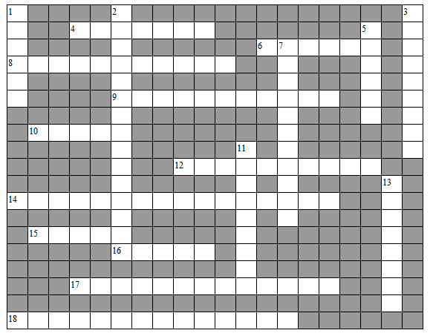
Directions: Complete and crossword puzzle and answer the extended response questions. Once you have finished staple this sheet to your extended response and put it in your period’s box. This is to be completed by the end of the class period.
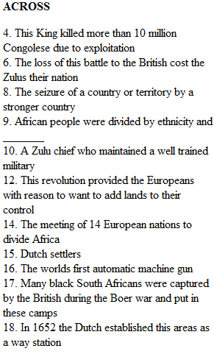

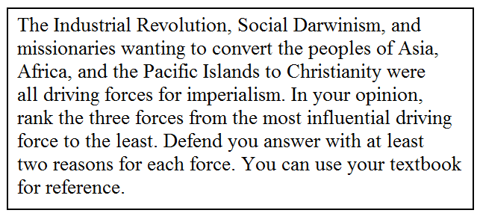
Extended Response: Answer the following questions on a separate sheet of paper.
