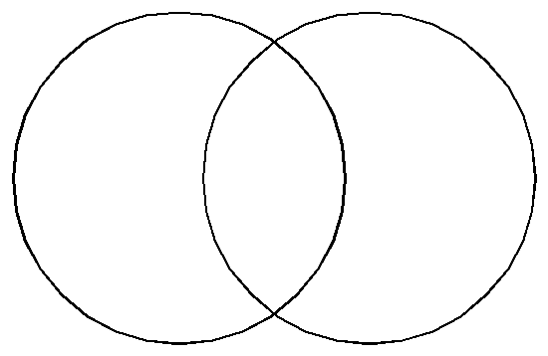
Compare and Contrast Imperialism of Africa and the Middle East
AFRICA
MIDDLE EAST
African versus Muslim Imperialism Venn Diagram
Sections 27.1, 27.2 & 27.3 discuss two different styles of European conquest and imperialism: the Scramble for Africa and taking control of Muslim lands.
Use the Venn diagram to compare and contrast the different aspects of African and Muslim society. You must include aspects the following: government structure before imperialism, economic structure before and after imperialism, actions of various leaders and the results of those actions, imperialism's effects on the native culture, which European countries colonized each area, the type of imperial control that was established, and the natural resources that were exploited. In the overlapping areas list the similarities. In the areas that do not overlap show the differences.
The Venn Diagram will go on the left side in you notebook, after it has been graded.

