World War I Technology

Excerpt taken from online article:
http://www.ieee-virtual-museum.org/collection/event.php?id=3456962&
From the onset, those involved in the war were aware that technology would make a critical impact on the outcome. In 1915 British Admiral Jacky Fisher wrote, “The war is going to be won by inventions.” New weapons, such as tanks, the zeppelin, poison gas, the airplane, the submarine, and the machine gun, increased casualties, and brought the war to civilian populations. The Germans shelled Paris with long-range (60 miles or 100 kilometers) guns; London was bombed from the air for the first time by zeppelins.
World War I was also the first major war that was able to draw upon electrical technologies that had been in development at the turn of the century. Radio, for example, became essential for communications. The most important advance in radio was the transmission of voice rather than code, something the electron tube, as oscillator and amplifier, made possible. Electricity also made a huge impact on the war. Battleships, for example, might have electric signaling lamps, an electric helm indicator, electric fire alarms, remote control—from the bridge—of bulkhead doors, electrically controlled whistles, and remote reading of water level in the boilers. Electric power turned guns and turrets and raised ammunition from the magazines up to the guns. Searchlights—both incandescent and carbon-arc—became vital for nighttime navigation, for long-range daytime signaling, and for illuminating enemy ships in night engagements.
Submarines also became potent weapons. Although they had been around for years, it was during WWI that they began fulfilling their potential as a major threat. Unrestricted submarine warfare, in which German submarines torpedoed ships without warning—even civilian ships belonging to non-combatant nations such as the United States—resulted in the sinking of the Lusitania on 7 May 1915, killing 1,195 people. Outrage over the Lusitania and other sinkings, coupled with other factors, brought the United States out of its isolationism to declare war on Germany in 6 April 1917. Finding ways to outfit ships to detect submarines became a major goal for the allies. Researchers determined that allied ships and submarines could be outfitted with sensitive microphones that could detect engine noise from enemy submarines. These underwater microphones played an important part in combatting the submarine threat. The Allies also developed sonar, but it came too close to the end of the war to offer much help.

World War I Technology
Images

Directions: List the areas of technology that each of the images relate to.

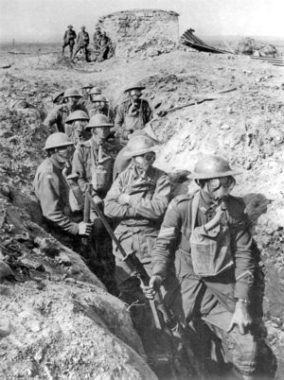 ________________________________

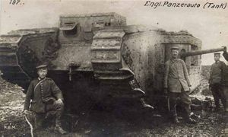 ______________________________
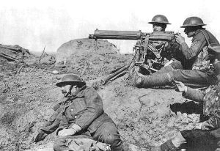 ______________________________

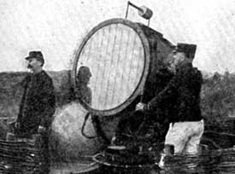 ______________________________

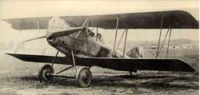 ______________________________

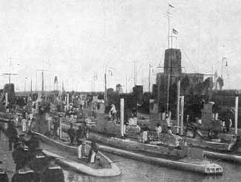 ______________________________

Excerpt from German’s Gas War Decided on in 1908
New York Times. Nov. 16th 1915.

“The French authorities have entrusted us with the whole ambulance service of the Eleventh Army Corps,” says Mr. Norton, and, briefly reviewing this years work, he adds that the American Corps has carried nearly 28,000 cases and that from the 25th of September to the 9th of October the American cars relieved the sufferings of over 6,000 individuals….

…“we fixed the masks on the wounded and on ourselves”, writes Mr. Norton. “and after about two hours the Germans let up and we were able to take a long breath and express our feelings of the man who invented this dirty way of fighting.”

Total Mortality Figures From WWI

Country | Dead | Wounded | Missing | Total
Africa | 10,000 |  |  | 10,000
Austrailia | 58,150 | 152,170 | - | 210,320
Austria-Hungary | 922,000 | 3,600,000 | 855,283 | 5,377,283
Belgium | 44,000 | 450,000 | - | 494,000
Britain | 658,700 | 2,032,150 | 359,150 | 3,050,000
Bulgaria | 87,500 | 152,390 | 27,029 | 266,919
Canada | 56,500 | 149,700 |  | 206,200
Caribbean | 1,000 | 3,000 |  | 4,000
France | 1,359,000 | 4,200,000 | 361,650 | 5,920,650
Germany | 1,600,000 | 4,065,000 | 103,000 | 5,768,000
Greece | 5,000 | 21,000 | 1,000 | 27,000
India | 43,200 | 65,175 | 5,875 | 114,250
Italy | 689,000 | 959,100 |  | 1,424,660
Japan | 300 | 907 | 3 | 1,210
Montenegro | 3,000 | 10,000 | 7,000 | 20,000
New Zealand | 16,130 | 40750 |  | 56,880
Portugal | 7,222 | 13,751 | 12,318 | 33,291
Romania | 335,706 | 120,000 | 80,000 | 535,706
Russia | 1,700,000 | 5,000,000 | - | 6,700,000
Serbia | 45,000 | 133,148 | 152,958 | 331,106
South Africa | 7,000 | 12,000 | - | 19,000
Turkey | 250,000 | 400,000 | - | 650,000
United States | 58,480 | 189,955 | 14,290 | 262,725

