Instructions for Writing an Obituary
- The following are historical leaders we will be discussing during this unit (Vladimir Lenin, Rasputin, Joseph Stalin, Sun Yixian, Jiang Jieshi, Mao Zedong, Mohandas Gandhi, Mustafa Kemal). You will be assigned one to create an Obituary for as your title page.
- Identify the birth and death dates for the individual
- Identify the birth and death locations for the individual
- List at least 2 of their accomplishments
- Explain the individuals historical significance
- Identify any family members that may have survived the individual
- Keep your obituary short and to the point. Less than 3 paragraphs
- Find a picture of the individual
- Limit your obituary to 100-125 words
Example:
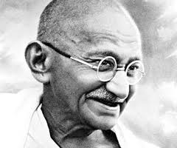

Mohandas K. Gandhi
Oct. 2, 1869- Jan 30, 1948
Gandhi was born to Hindu parents in the state of Gujarat in western India. He married Kasturbai Makanji at the age of 13. He studied law in London, England. He practiced law in South Africa working for the rights of immigrant Indians before returning to India to lead the long struggle for independence from Britain. His use of nonviolent protest and religious tolerance earned him the respect and support of the Indian people.
His goal for the independence of India was accomplished in 1947, but he was killed by an assassin as he walked through New Delhi to take evening prayers on January 30, 1948j.
He was survived by his four sons but was predeceased in death by his beloved wife of many years.

