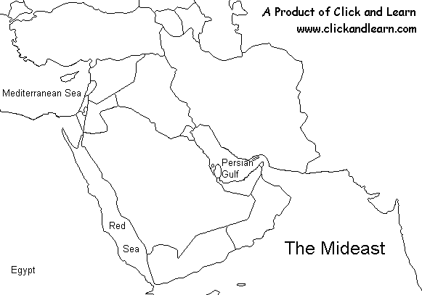
Caspian Sea
Black Sea
Arabian Sea
Gulf of Aden

